**Aim**

To write a C program that displays every 5th element of an array.

**Algorithm**

1. Start
2. Input size of the array and its elements
3. Traverse the array using a loop with step size i += 5 (start at index 4 because array index begins at 0)
4. Print each 5th element (i.e., positions 5, 10, 15, …)
5. Stop

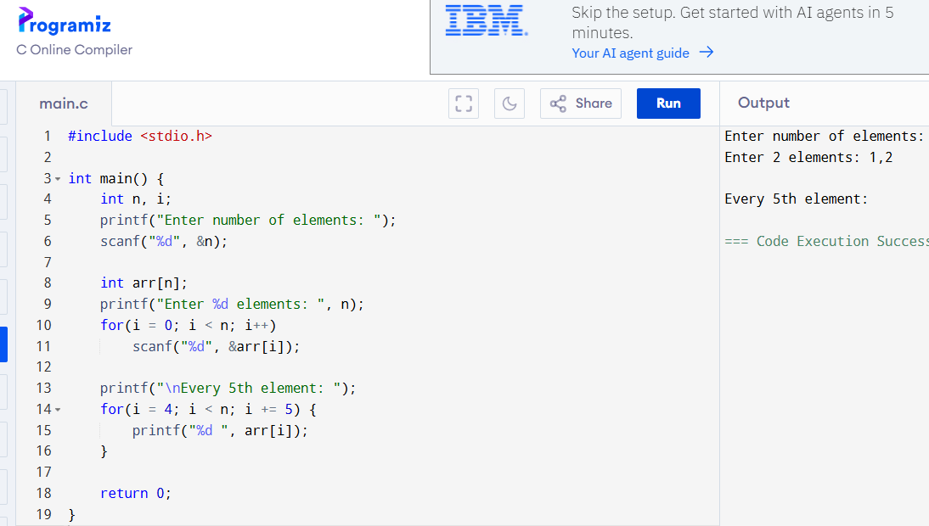

**Output**

Every 5th element: 55 100